**Project Planning Phase**

**Project Planning Template (Product Backlog, Sprint Planning, Stories, Story points)**

|  |  |
| --- | --- |
| Date | 02 November, 2022 |
| Team ID | PNT2022TMID08044 |
| Project Name | DEEP LEARNING FUNDUS IMAGE ANALYSIS FOR  EARLY DETECTION OF DIABETIC RETINOPATHY |
| Maximum Marks | 8 Marks |

**Product Backlog, Sprint Schedule, and Estimation (4 Marks)**

Use the below template to create product backlog and sprint schedule

| **Sprint** | **Functional Requirement (Epic)** | **User Story Number** | **User Story / Task** | **Story Points** | **Priority** | **Team Members** |
| --- | --- | --- | --- | --- | --- | --- |
| Sprint-1 | Registration | USN-1 | As a user, I can register for the application by using government certified IDs. | 6 | High | Tejaswini |
| Sprint-1 | Authentication | USN-2 | As a user, I will authenticate using ID credentials. | 8 | High | Varsha,  Tejaswini |
| Sprint-1 | Login | USN-3 | With the credentials the user can login easily. | 6 | Low | Varshini |
| Sprint-2 | Training the system | USN-4 | Model is trained with all different images of diabetic retinopathy and in different dimensions. | 10 | Medium | Kala sree,  Tejaswini |
| Sprint-2 | Implementation | USN-5 | The model is implemented to check its working and accuracy. | 10 | Medium | Varsha,  Varshini |
| Sprint-3 | Classification | USN-6 | Classify the images into Normal images and DR images | 10 | High | Tejaswini,  Varshini |
| Sprint-3 | Prediction | USN-7 | Predict the output of which DR level will be the output | 10 | High | Kala sree,  Varshini |
| Sprint-4 | Final Output | USN-8 | On accurate detection of diabetic retinopathy in early time will be save the eye-vision | 10 | High | Varsha,  Kala sree |
| Sprint-4 | Controls and has overview of entire process | USN-9 | The customer needs are checked and satisfied.  Handle any sort of emergency and get it fixed. | 5 | Medium | Varsha |
| Sprint-4 | Database | USN-10 | All the past datas are collected and stored for future reference. | 5 | Low | Kala sree |

**Project Tracker, Velocity & Burndown Chart: (4 Marks)**

| **Sprint** | **Total Story Points** | **Duration** | **Sprint Start Date** | **Sprint End Date (Planned)** | **Story Points Completed (as on Planned End Date)** | **Sprint Release Date (Actual)** |
| --- | --- | --- | --- | --- | --- | --- |
| Sprint-1 | 20 | 7 Days | 24 Oct 2022 | 29 Oct 2022 | 20 | 30 Oct 2022 |
| Sprint-2 | 20 | 7 Days | 31 Oct 2022 | 05 Nov 2022 | 20 | 06 Nov 2022 |
| Sprint-3 | 20 | 7 Days | 07 Nov 2022 | 12 Nov 2022 | 20 | 13 Nov 2022 |
| Sprint-4 | 20 | 7 Days | 14 Nov 2022 | 19 Nov 2022 | 20 | 20 Nov 2022 |

**Velocity:**

Imagine we have a 10-day sprint duration, and the velocity of the team is 20 (points per sprint). Let’s calculate the team’s average velocity (AV) per iteration unit (story points per day)

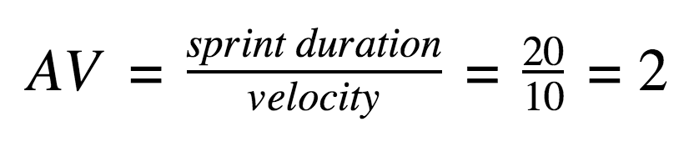

Average velocity(AV)= 20/7=2.85

**Burndown Chart:**

A burn down chart is a graphical representation of work left to do versus time. It is often used in agile[software development](https://www.visual-paradigm.com/scrum/what-is-agile-software-development/) methodologies such as [Scrum](https://www.visual-paradigm.com/scrum/scrum-in-3-minutes/). However, burn down charts can be applied to any project containing measurable progress over time.

